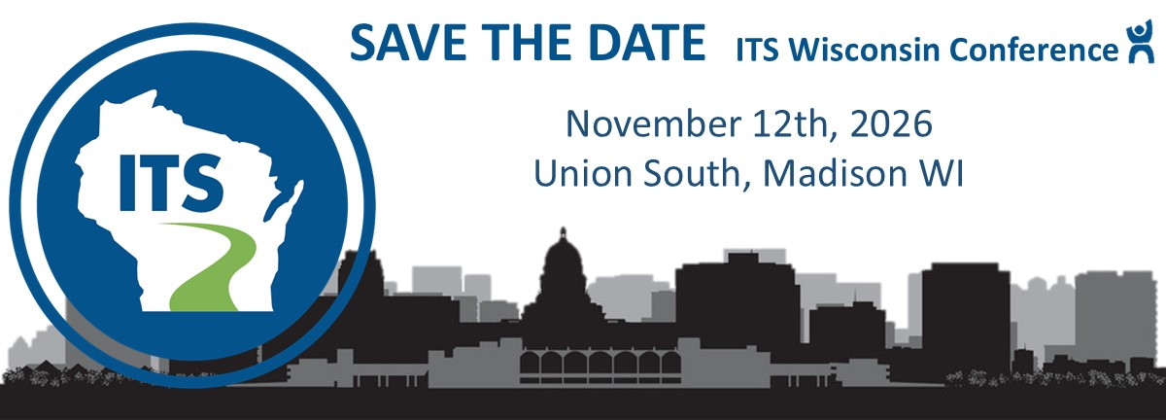

CALL FOR ABSTRACTS

ITS Wisconsin invites interested parties to submit abstracts to participate in the 2026 ITS Wisconsin Transportation Conference to be held on November 12th, 2026 in Madison, Wisconsin. ITS Wisconsin seeks abstracts regarding intelligent transportation technologies, their application, and their benefits to our communities. The following are example topic areas:

- Automated and Connected Vehicles
- Transportation Systems Management and Operations
- Traffic and Incident Management
- Systems and Signal Performance Measures
- Integrated Corridor Management
- Artificial Intelligence
- Cybersecurity and Privacy
- Smart Cities
- Multimodal Systems

- Smart Work Zones
- Electrification
- Freight
- ITS Workforce
- ITS Policy and Funding
- HOT/Express Lanes/Tolling
- Emerging Technology
- Safety
- Mobility
- Equity

Abstracts should emphasize how technology helps transportation professionals to design, build, and operate safe, efficient, and environmentally responsible systems while advancing equity in our communities.

The deadline to submit abstracts is July 10th, 2026.

Interested parties may complete the attached form.

2026 ITS Wisconsin Transportation Conference
Abstract Submission Form
Submission Instructions: Please complete all fields below. Submit in PDF format with “ITS Transportation Conference 2026 Abstract” in subject line to Jacey.Reiman@oneatlas.com
Deadline for submission: July 10, 2026
Please provide information as you would like it to appear in the program should your abstract be selected for presentation.
Title of Presentation
Presenter Name(s)
Presenter Title(s)
Affiliation(s)
Contact Information
Email(s)
Telephone(s)
Address(es)

Abstract: Enter your abstract below. Maximum of 500 words.

